

**MARKING GUIDE**

**GEOGRAPHY TEACHERS’ NETWORK (GTN)**

**Uganda Advanced Certificate of Education**

GEOGRAPHY

**Paper 3**

**STANDARDS**

1. The whole paper is to be marked by impression unless otherwise stated from a particular question or part of the questions.
2. Candidates should exhibit ability to explain, discuss and illustrate the points raised.
3. A mere outline of points should not attract more than half of the marks allocated to the question or section.

***Awards***

*An excellent answer scores 21 – 25 marks*

*A very good answer scores 18 – 20 marks*

*A good answer scores 15 – 17 marks*

*A fairly good answer scores 13 – 14 marks*

*An average answer scores 10 – 12 marks*

*A below average answer scores 08 – 09 marks*

*A fail answer scores 01 – 07 marks*

*An irrelevant answer scores 00 - 06 marks*

**SECTION A: FIELD WORK**

*Choose* **one** *question*

1. For any field work carried out either as a class or an individual;
2. State the;
3. Topic (02 marks)

*Candidates should bring out topic of study clearly showing* ***what***  *was studied*  ***where***  *the study took place.*

*NB: The topic should be geographical and bear a relationship.*

1. Objectives of the study. (05 marks)

*The objectives should be* ***precise***  *clear, measurable and in a short time, and related to the topic of study.*

*Accept phrases like - to find out*

* *To investigate*
* *To discover*
* *To identify etc*

*Reject phrases like - To know*

* *To understand*
* *To appreciate*
* *To admire*
* *To see etc*

*NB: No objective should repeat the topic directly*

1. How did you use the following methods to collect data from the field?

*Candidates are expected to;*

* *Define the method with tools used - 01*
* *Describe how it was used - 01*
* *Give information collected from the field - -1*

1. Questionnaires

*Setting of pre – determined questions on a question paper and sending them to specific people in the field for written responses……*

1. Estimation

*Use of non – caliberated instruments like ropes, sticks, strides, etc to establish the distance, size, height, etc of objects, there after converting the measurements to a known standard measure .*

1. Tabulation (09 marks)

*Use of tables to collect and process the data while in the field.*

1. Outline the advantages of the methods in 1(b) above. (03 marks)
2. ***Questionnaires***

* *Saved time for visiting the field*
* *Encouraged correct or facital information since the identity of the respondent was hidden.*
* *Information was easily stored for future use, since it was written etc*

*Any 1 x 1 = 1 mark*

1. ***Estimation***

* *Was cheap since never required expensive tools*
* *It was time saving since the measuring tools were improvised.*
* *Etc any 1 x 1 = 1 mark*

1. ***Tabulation***

* *Saved time by putting information in tables*
* *Simplified work*
* *Etc Any 1 x 1 = 01 mark*

***NB:*** *The advantages should be in past tense*

*They should be attached to the method*

1. Explain the post fieldwork activities you carried out. (06 marks)

*Post field work activities may include:*

* *Data analysis*
* *Report writing*
* *Sorting of information*
* *Discussions at group and class level*
* *Data presentation*
* *Data tabulation*
* *Compared data*
* *Polished the sketches*
* *Disserminationo f the report*
* *Etc any 6 x 1 = 6 marks*

*Total 25 marks*

1. For any fieldwork carried out on an urban area;
2. State the topic and objectives of the study. (06 marks)

*Candidates are expected to come up with a topic of study clearly showing;*

* *What was studied*
* *Where the study was conducted*
* *The name of the urban centre*
* *And geographical relationship = 2 marks)*

*The candidate is expected to come up with objectives stated as;*

* *To find out ……..*
* *To investigate……..*
* *To discover…………*
* *To identify…….*
* *To establish……*
* *To assess……*
* *To determine…….*

*Do not accept phrases like*

* *To know……*
* *To see…….*
* *To understand……*
* *To appreciate…..*
* *To suggest…..*
* *Etc 4 x 1 = 4 marks*

1. Draw an annotated land scape sketch of the area studied and on it mark and name;
2. A drainage feature
3. The urban area and;
4. Vegetation types. (08 marks)

*Candidates are expected to draw, mark and label a panorama*

*Award as follows:-*

* *Mi - 04*
* *Urban centre - 01*
* *A drainage feature - 01*
* *Two vegetation types - 02*

*Total 08 marks*

1. Examine the relationship between vegetation and land use in the area.

(04 marks)

*Candidates are expected to come up with at aleast two relationships between vegetation and land use.*

* *Relationship - 01*
* *Accountability - -1*

1. Explain the factors that influenced the development of the urban area.

(07 marks)

*Candidates should come up with factors for the development of the urban centre with clear evidence in form of place name or direction.*

*The factors may include:-*

* *Site advantages*
* *Capital availability*
* *Adequate labour*
* *Infrastructural developments like roads etc*
* *Government policy*
* *Presence of water sources*
* *Rich urban field.*
* *Presence of employment opportunities*
* *Etc 7 x 1 = 7 marks*

*NB: Only accept factors with evidence of place names or direction*

*NB: No name of urban centre any where in the answer, no mark at all*

*Total 25 marks*

**SECTION B : UGANDA**

**Choose three questions from this section**

1. Examine the effect of down warping on the drainage of Uganda. (25 marks)

***Answer***

*The candidate is expected to define the term down warping, trace for its origin and its effect on drainage feature formation.*

***Definition***

*Down warping refers to the distortion of the earth crust due to pressure from either side of the rock during compression.*

***Or***

*Is the downward movement of the land due to pressure from either side of the rock during compression.*

*(02 marks)*

***Origin***

*Down warping resulted from compressional forces caused by* ***geo – chemical reactions***  *and* ***radio activity***  *resulting from heat and pressure which led to* ***convective currents***  *movement in a converging form producing* ***compression forces.***

***Effects of down warping on the drainage of Uganda***

1. *Led to the formation of down warped lakes like* ***L. Victoria****, lake Kyoga, Lake Wamala, Lake Kwamia etc*

*Compressional forces led to up warping of the eastern and western parts while the central area was down warped creating a depression that was later filled with water from rainfall and the reversed rivers.*

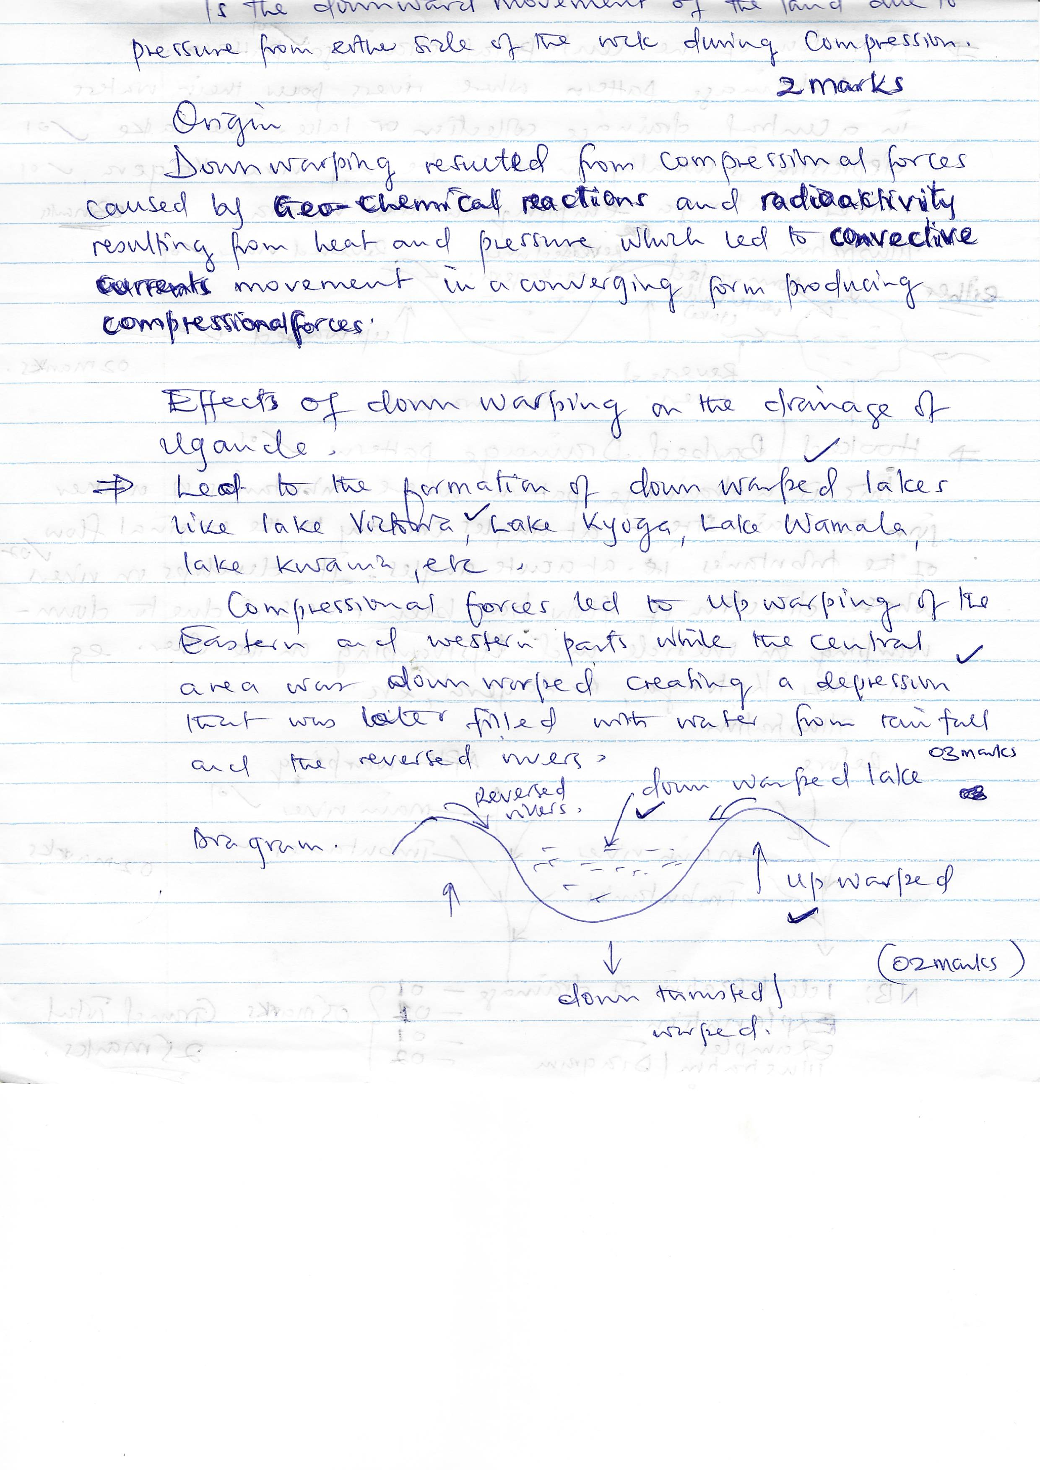

1. *Drainage reversal*

*Following the uplifting of the western and eastern parts, rivers flowing away from the central part were forced to flow back hence drainage reversl e.g. river Katonga, River Kagera, R. Kafu etc*

***Illustration***

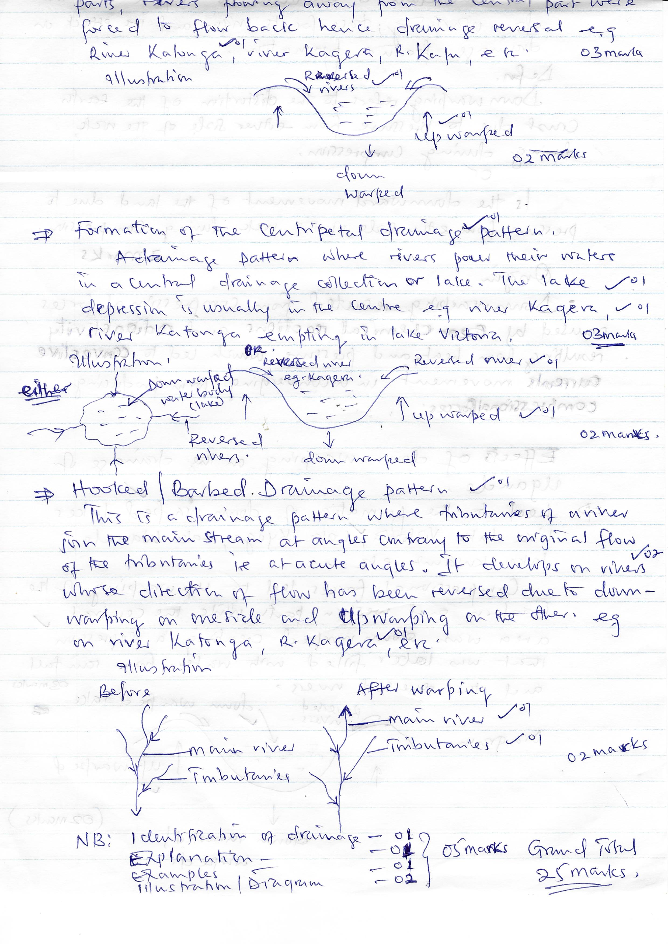

1. *Formation of the centripetal drainage pattern.*

*A drainage pattern were rivers pour their waters in a central drainage collection or lake. The lake depression is usually in the centre e.g. river Kagera, river Katonga empting in lake Victoria*

**

1. *Hooked / barbed. Drainage pattern*

*This is a drainage pattern where tributaries of a river join the main stream at angles contrary to the original flow of the tributaries i.e. at acute angles. It developes on rivers whose direction of flwo has been reversed due to down warping on one side and up warping on the other side e.g. on river Katonga, R. Kagera etc*

***Illustration***



*NB: Identification of drainage - 01 m*

*Explanation - 01*

*Examples - 01*

*Illustration / diagram - 02*

*Grand total = 25 marks*

1. (a) Discuss the challenges of plantation farming in Uganda. (17 marks)

*Candidates are expected to define plantation farming as;*

*Plantation farming refers to the growing of a single perennial crop on a very large scale using scientific means for commercial purpose.*

*Candidates should identify the different plantational crops and their respective location. E.g. sugarcane at Kakira in Jinja, Lugazi in Buikwe, Kinyara in Masindi, Sango bay in Rakai etc*

* *Tea at Kasaku in Buikwe, Bakijurura tea estate in Mityana, Igara tea estate in Bushenyi, Mukwano tea estate in*
* *Palm oil at Kalangala, Bubuma, etc*
* *Coffee at aKaweri*

*Candidates should then represent the above on a sketch map*

* *Mere identification without a sketch map – 03*
* *Sketch map with correct information - 05 marks*

*The challenges may include:-*

* *Limited land / poor land tenure system*
* *Limited capital*
* *Pests and disease attacks*
* *Prolonged drought*
* *Natural calamities like stormy, rains, floods etc*
* *Poor transport of communication links*
* *Limited research*
* *Limited technology*
* *Limited labour force*
* *Land conflicts.*
* *Limited processing plants*
* *Poor government policy*
* *Limited market*
* *Limited power and energy supply*
* *Soil exhaustion due to monoculture*

*Any 12 x 1 = 12 marks*

(b) What steps are being taken to promote plantation farming n Uganda?

(08 marks)

* *Providing land*
* *Changing the land tenure system*
* *Acquisition of loans*
* *Carrying research*
* *Improving or importing technology*
* *Improving on the transport network*
* *Market search and expansion*
* *Settling up processing plants*
* *Extension of power to plantational areas*
* *Increased training of labour*
* *Increased use of irrigation*
* *Application of fertilizers*
* *Etc Any 8 x 1 = 8 marks*

*NB: Points should be illustrated with a plantation crop and where. (place*

*name) Total = 25 marks*

1. To what extent have natural resources favoured the development of power and energy in Uganda? (25 marks)

*Candidates are expected to give the status of the energy sector e.g.*

* *Uganda has the biggest solar installation in the sub – Saharan region at Kalangala.*
* *Bio mas is the most used type of energy*
* *H.E.P contributes 1% of the energy use.*
* *More dams for HEP are being constructed*
* *HEP is the most used for industrial purpose*
* *Solar energy is the most abundant*
* *Etc Any 2 x 1 = 2 marks*

*Candidates are expected to identify the form of power and where it is found e.g.*

* *Solar energy in Kampala, Mayuge, Kalangala etc*
* *Thermal energy in Mukon, Moroto, Arua etc*
* *HEP from Nalubaale dam on River Nile in Jinja*
* *Wind energy in Kotido Kaabong*
* *Biomas from Mabira in Buikwe etc*
* *Etc*
* *Represent the above on the sketch map of Uganda*
* *Mere outline of the power and energy sector in Uganda. – 03 marks*
* *Sketch map with correct information - 05 marks*

*The candidate should begin with physical factors then the human factors e.g.*

* *Presence of rivers with water falls for HEP*
* *Abundant / long hours of sunshine for solar*
* *Strong winds for wind energy*
* *Presence of forests for Biomas*
* *Presence of petroleum from Bulisa for Thermal energy*
* *Narrow gore for HEP production*
* *Presence of the hard old basement rock e.g.at Nalubale dam for HEP production*

*Any 5 x 2 = 10 marks*

***However, other factors***

* *Large market for power and energy*
* *Adequate capital*
* *Abundant labour force*
* *Improved transport and communication network*
* *Positive government policy*
* *Increased research*
* *Improved technology*
* *Political stability / improved security*
* *Etc any 8 x 1 = 8 marks*

*NB: Points should be illustrated with type of power and energy and place name.*

*Total = 25 marks*

1. (a) Assess the factors for the detoriation of the wetland resources in Uganda.

(17 marks)

*Candidates should define wetland detoraiation resource as reproduction in the productivity of wetlands.*

* *Identify the types of wetlands and give their locations*
* *Lacustrine e.g. Lutembe around lake Victoria the Lake Kyoga Swamp complex*
* *Open wetland e.g. Nyamuriro wetland in Kabale, Nambigirwa in Wakiso etc*
* *Riverine wetlands e.g. R. Katonga swamp, R. Mayanja, Kagera, wetland etc*
* *Draw a sketch map to represent the above information.*
* *Mere identification with in map*
* *A sketch map representing the information above.*

***Factors***

* *Prolonged drought*
* *Wild animals*
* *Pests and diseases*
* *Brick making*
* *Deforestation of the riverine forests*
* *Waste dispersal in wetlands*
* *Clay and sand mining in wet lands*
* *Farming in wetlands*
* *Bush fires due to bush burning in the dry season*
* *Urban expansion into the wetlands*
* *Settlement in the wetlands*
* *Tree planting (afforestation of Eucalyptus) in wetlands*
* *Pollution from industry wastes*
* *Wetland resources / vegetation harvesting e.g. papyrus*
* *Road construction*
* *Swamp draining*
* *Over grazing / wildlife conservation*
* *Etc*

*NB: Points should be explained and illustrated using a wetland and a place name. Any 10 x 1 = 10 marks*

(b) What measures are being taken to conserve the wetland resources in Uganda? (08 marks)

***Measures to conserve wetlands in Uganda***

* *Parliamentary legislation and district bylaws against wetland destruction*
* *Restriciting brick making in wetlands*
* *Evictions and prosecution of wetland encroachers*
* *Demarcation wetland boundaries*
* *Constant monitoring of wetland areas*
* *Gazetting and establishing industrial zones to avoid industries being set up any where*
* *Treating industrial wastes before releasing them into wetlands.*
* *Treat signing like the RAMSAR*
* *Gazetting of wetlands*
* *Cancelling land titles for land located in wetlands*
* *Restricting farming in wetlands*
* *By laws against bush burning*
* *Restricting grazing in wetland areas*
* *Creating of bodies like NEMA*
* *Creating of projects like the lake Victoria initiative, the water reed project etc*
* *Sensitizing the local people*
* *Etc*

*NB: Examples should be the name of the wetland and place / location.*

*Any 8 x 1 = 8 marks*

*Total = 25 marks*

1. (a) Account for the expansion of urban centres in Uganda. (15 marks)

*Candidates should define the term urban centre as:*

*This refers to a developed area with more people and modern buildings.*

***OR***

*It refers to a centre of development etc*

*Candidates are also expected to bring out the different categories of urban centres with examples e.g.*

* *Capital city – Kampala*
* *Cities like Jinja, Mbarara, Gulu, Mbale, etc*
* *Municipalities like Mukono, Mubende, Iganga, Kamuli, Entebbe, Kabale etc*
* *Town councils like Wakiso, Luwero, etc*
* *Town boards like semuto, Namawojolo etc*

*Candidates are then expected to draw a sketch map clearly representing the urban categories above.*

*NB:*

* *Mere mention of urban categories with examples*
* *Representation of the urban categories with the sketch map*

***Factors for the expansion may include:***

* *Availability of more land for expansion*
* *More capital availability*
* *Increased training of the technical staff / more labour*
* *Positive / supportive government policy*
* *Improved infrastructural development*
* *Increased research*
* *Improved technology*
* *Increased rural urban migrations*
* *Increased birth rates – more people hence urban expansion*
* *Increased supply of food items*
* *Expansion of the urban field*
* *Improved political state and security*

*NB: Points should be illustrated with urban category and name*

*any 10 x 1 = 10 marks*

(b) Examine the functions of urban centres in reference to the recently created cities. (10 marks)

* *The functions include:-*
* *They act as religious centres*
* *They are commercial centres / trading centres*
* *They are administrative centres*
* *They act as centres of communication and transport*
* *They are education centres*
* *They act as accommodation centres*
* *They act as security centres*
* *They act as tourist centres*
* *Etc*

*NB: Points should be illustrated with examples of recently created cities*

*only. Any 8 x 1 = 8 marks*

*Total 25 marks*

1. Study the table below showing number of tourists who visited selected National Parks of Uganda in 2021 and answer questions that follow:

|  |  |
| --- | --- |
| **National park** | **No. of tourists** |
| QENP | 34,000 |
| Kidepo National Park | 13,000 |
| Bwindi National Park | 36,341 |
| M.F.N.P | 50,000 |
| Total | 133,341 |

1. Draw a compound bar graph to represent the information in the table above. (07 marks)

* *The candidate is expected to come up with a cumulative table for the compound*
* *The candidate has two options, i.e. either to draw a compound bar graph using the absolute figures as shown on the graph paper or calculate out the percentage and therefore draw a percentage compound bar graph.*

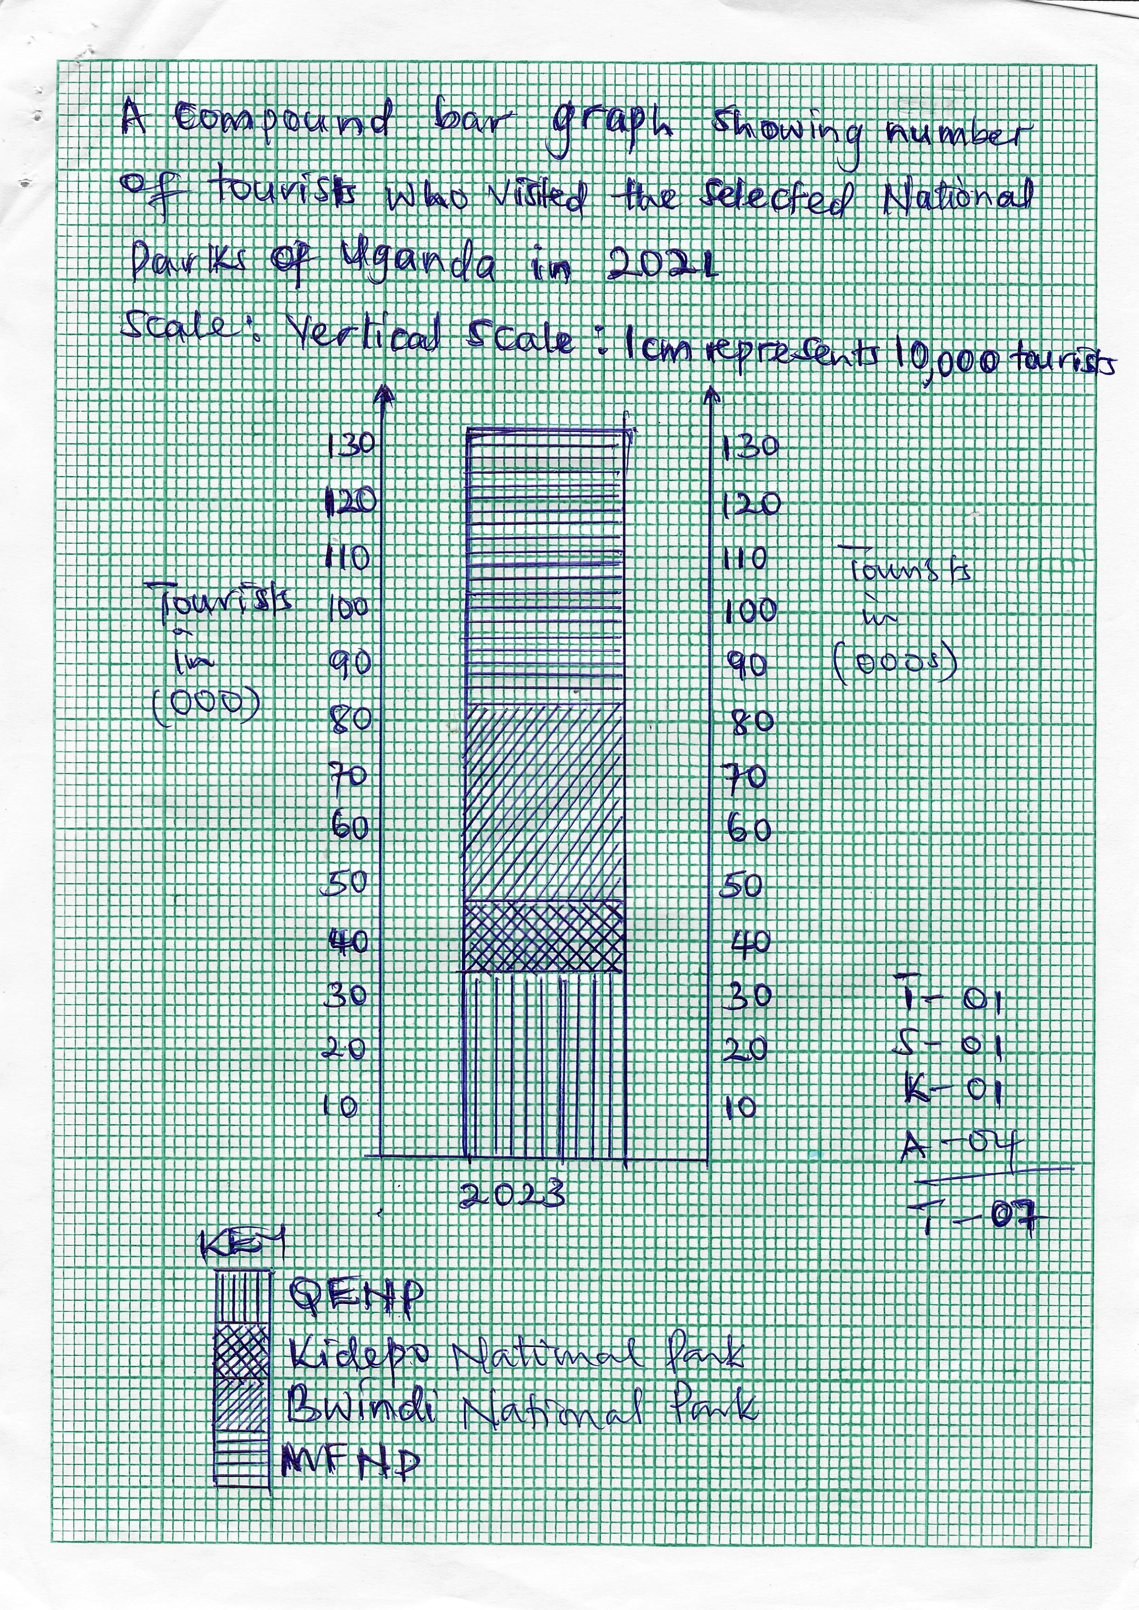

1. Account for the highest number of tourist received by one of the national parks in the table. (06 marks)

* *Candidates should begin by indentifying the national park then account for it receiving the highest number of tourists.*

***Answer***

***MFNP (Murchison Fall national park)***

* *Highly accessible*
* *Has a lot of different animals*
* *Has more tourist attractions out side wildlife e.g. the water fall*
* *High security*
* *Strategic location of the national park*
* *It’s the largest national park in the country*
* *Has the big four mammals – lion, leopard, buffalo and elephants*
* *The varied and beautiful scenery*
* *Tree climbing lions*
* *The hot air balloon experience*
* *The chimpanzee trekking*
* *Sport fishing in Murchison falls national park*
* *Etc any 6 x 1 = 6 marks*

1. Discuss the steps being taken by the tourism sector to promote local tourism in Uganda. (12 marks)

* *Steps being taken to promote local tourism*
* *Advertising on local media channels / tourist exhibition*
* *Offering public holiday packages for groups*
* *Research into activities for local tourists*
* *Improving on road transport, use of hot balloons etc*
* *Setting up more tour and travel companies*
* *Reducing entrance for the national parks for the wildlife members (those with wildlife cars*
* *More capital*
* *Increased training of labour to handle local tourists*
* *Encouraging schools through special packages*
* *Improving on the security*
* *Restocking of endangered wildlife species*
* *Giving back to the community on the revenue raised from tourism*
* *Sensitizing the local community*
* *Etc any 12 x 1 = 12 marks*

**END**